Abstract Factory

Formål
Abstract Factory er et design pattern, der gør det muligt at fremstille familier af relaterede objekter uden at angive deres konkrete klasser.

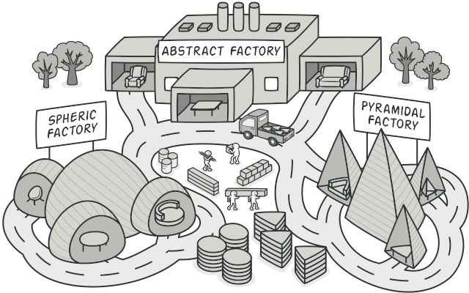

Problem
Forestil dig, at du laver en møbelforretning-simulator. Din kode består af klasser, der repræsenterer:
- En familie af relaterede produkter, fx: Stol + Sofa + Sofabord.
- Flere varianter af denne familie, fx: Moderne, Victoriansk og ArtDeco.
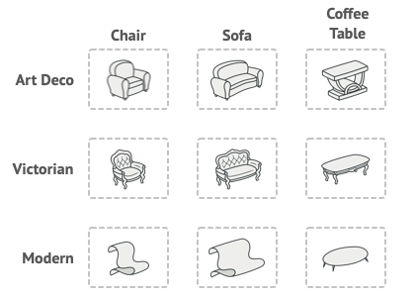
Figur 1. Product families and their variants.

Du skal kunne skabe individuelle møbelobjekter, som passer sammen inden for samme produktfamilie.

Kunder bliver ikke glade, hvis de får møbler, der ikke matcher hinanden!

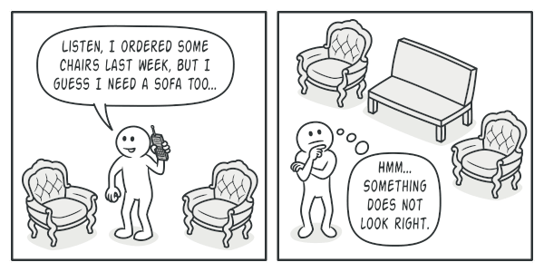
Figur 2. A Modern-style sofa doesn’t match Victorian-style chairs.

Derudover ønsker du ikke at skulle ændre eksisterende kode hver gang du tilføjer nye produkter eller produktfamilier til programmet. Møbelkataloger ændres ofte, så det skal være nemt at udvide uden at ændre kernen af programmet.

Løsning
Abstract Factory-mønstret foreslår først, at man udtrykkeligt erklærer grænseflader (interfaces) for hver type produkt i familien (fx stol, sofa, sofabord). Derefter får man alle varianter af et produkt til at implementere deres respektive interface.
For eksempel:

Alle stole-varianter implementerer interfacet Chair.

Alle sofaborde implementerer interfacet CoffeeTable.

På den måde samles alle varianter af samme produkt i én klassehierarki.

Dernæst defineres Abstract Factory — et interface, der indeholder en liste af fabriksmetoder for at skabe hvert produkt i familien (fx createChair(), createSofa(), createCoffeeTable()).
Disse metoder returnerer de abstrakte produkttyper (Chair, Sofa, CoffeeTable), som vi netop definerede.

Hver konkret fabrik (fx ModernFurnitureFactory) implementerer derefter Abstract Factory-interfacet og producerer en bestemt produktvariant:

ModernFurnitureFactory laver kun ModernChair, ModernSofa, ModernCoffeeTable.

VictorianFurnitureFactory laver kun VictorianChair, VictorianSofa, VictorianCoffeeTable.

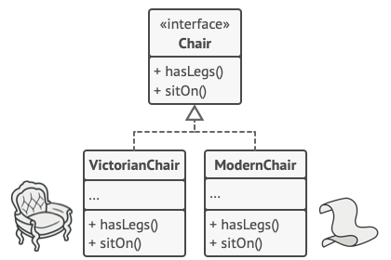
Figur 3. All variants of the same object must be moved to a single class hierarchy.

Klientkoden arbejder udelukkende med de abstrakte interfaces, både for produkter og fabrikker.
Det betyder, at du kan ændre, hvilken fabrik klienten bruger — og dermed hele møbelstilen — uden at ændre selve klientkoden.
Klienten ved ikke, om den arbejder med moderne eller victorianske møbler — den ved kun, at der findes en sitOn()-metode på alle stole.
Når applikationen starter, vælger den typisk, hvilken konkret fabrik der skal bruges, baseret på konfiguration eller miljø (fx valgt stil, OS, tema).
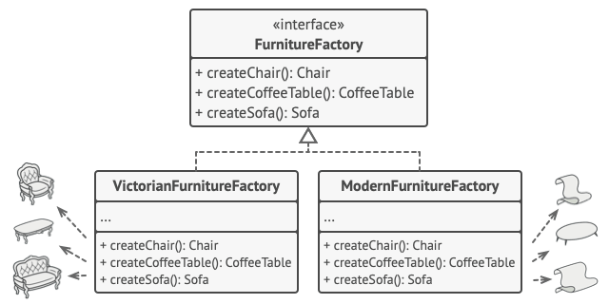
Each concrete factory corresponds to a specific product variant.

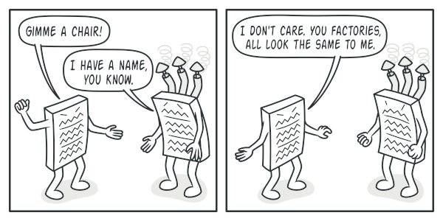
The client shouldn’t care about the concrete class of the factory it works with.

Struktur
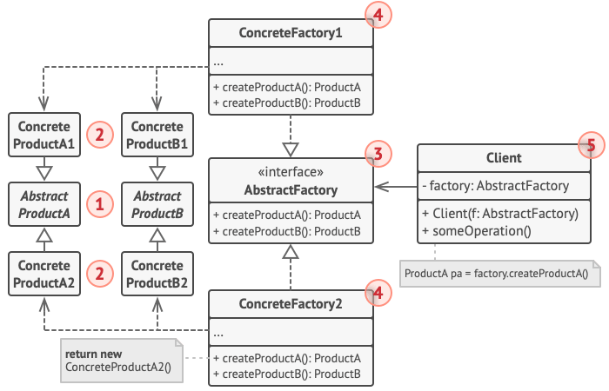

Abstract Factory designmønsterets struktur:
- Abstrakte produkter definerer interfaces for et sæt relaterede objekter (produktfamilien)
- Konkrete produkter implementerer disse interfaces og grupperes i varianter (Modern, Victorian osv.).
- Abstract Factory-interface definerer metoder til at skabe hvert af de abstrakte produkter.
- Konkrete fabrikker implementerer disse metoder og producerer kun én produktvariant.
- Klientkoden arbejder kun med abstrakte interfaces, og bliver derfor ikke afhængig af specifikke produktklasser.

Pseudocode
This example illustrates how the Abstract Factory pattern can be used for creating cross-platform UI elements without coupling the client code to concrete UI classes, while keeping all created elements consistent with a selected operating system.
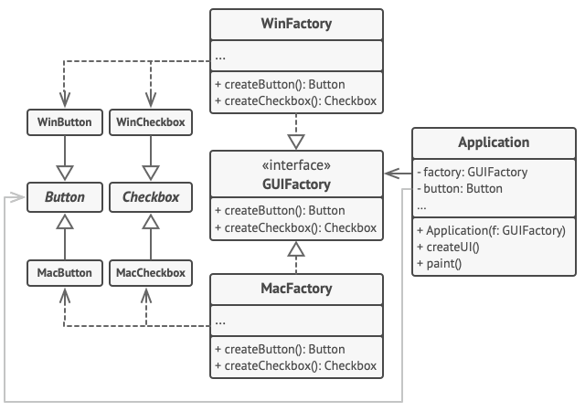
The cross-platform UI classes example.
The same UI elements in a cross-platform application are expected to behave similarly, but look a little bit different under different operating systems. Moreover, it’s your job to make sure that the UI elements match the style of the current operating system. You wouldn’t want your program to render macOS controls when it’s executed in Windows.
The Abstract Factory interface declares a set of creation methods that the client code can use to produce different types of UI elements. Concrete factories correspond to specific operating systems and create the UI elements that match that particular OS.
It works like this: when an application launches, it checks the type of the current operating system. The app uses this information to create a factory object from a class that matches the operating system. The rest of the code uses this factory to create UI elements. This prevents the wrong elements from being created.
With this approach, the client code doesn’t depend on concrete classes of factories and UI elements as long as it works with these objects via their abstract interfaces. This also lets the client code support other factories or UI elements that you might add in the future.
As a result, you don’t need to modify the client code each time you add a new variation of UI elements to your app. You just have to create a new factory class that produces these elements and slightly modify the app’s initialization code so it selects that class when appropriate.
// The abstract factory interface declares a set of methods that
// return different abstract products. These products are called
// a family and are related by a high-level theme or concept.
// Products of one family are usually able to collaborate among
// themselves. A family of products may have several variants,
// but the products of one variant are incompatible with the
// products of another variant.
interface GUIFactory is
method createButton():Button
method createCheckbox():Checkbox

// Concrete factories produce a family of products that belong
// to a single variant. The factory guarantees that the
// resulting products are compatible. Signatures of the concrete
// factory's methods return an abstract product, while inside
// the method a concrete product is instantiated.
class WinFactory implements GUIFactory is
method createButton():Button is
return new WinButton()
method createCheckbox():Checkbox is
return new WinCheckbox()

// Each concrete factory has a corresponding product variant.
class MacFactory implements GUIFactory is
method createButton():Button is
return new MacButton()
method createCheckbox():Checkbox is
return new MacCheckbox()

// Each distinct product of a product family should have a base
// interface. All variants of the product must implement this
// interface.
interface Button is
method paint()

// Concrete products are created by corresponding concrete
// factories.
class WinButton implements Button is
method paint() is
// Render a button in Windows style.

class MacButton implements Button is
method paint() is
// Render a button in macOS style.

// Here's the base interface of another product. All products
// can interact with each other, but proper interaction is
// possible only between products of the same concrete variant.
interface Checkbox is
method paint()

class WinCheckbox implements Checkbox is
method paint() is
// Render a checkbox in Windows style.

class MacCheckbox implements Checkbox is
method paint() is
// Render a checkbox in macOS style.

// The client code works with factories and products only
// through abstract types: GUIFactory, Button and Checkbox. This
// lets you pass any factory or product subclass to the client
// code without breaking it.
class Application is
private field factory: GUIFactory
private field button: Button
constructor Application(factory: GUIFactory) is
this.factory = factory
method createUI() is
this.button = factory.createButton()
method paint() is
button.paint()

// The application picks the factory type depending on the
// current configuration or environment settings and creates it
// at runtime (usually at the initialization stage).
class ApplicationConfigurator is
method main() is
config = readApplicationConfigFile()

if (config.OS == "Windows") then
factory = new WinFactory()
else if (config.OS == "Mac") then
factory = new MacFactory()
else
throw new Exception("Error! Unknown operating system.")

Application app = new Application(factory)

Anvendelse
Brug Abstract Factory, når:

Din kode skal arbejde med forskellige familier af relaterede produkter, men du ikke vil afhænge af deres konkrete klasser.

Du vil sikre, at produkterne, der bruges sammen, altid passer sammen.

Du har en klasse med mange fabriksmetoder og ønsker at udskille dem i en separat fabriksstruktur.

Mønstret gør det muligt at udvide systemet med nye produktvarianter uden at ændre eksisterende klientkode.

How to Implement
- Lav et skema (matrix) over produkttyper og deres varianter.
- Opret abstrakte produktinterfaces for hver produkttype.
- Få alle konkrete produktklasser til at implementere disse interfaces.
- Definér et Abstract Factory-interface med fabriksmetoder for hvert produkt.
- Implementér konkrete fabrikker, én for hver produktvariant.
- Tilføj initialiseringskode i applikationen, som vælger den rigtige fabrik baseret på konfiguration.
- Erstat alle direkte new-kald i koden med kald til fabriksmetoderne.

Pros and Cons

Fordele:
- Produkter fra samme fabrik passer altid sammen.
- Løs kobling mellem klientkode og konkrete produktklasser.
- Overholder Single Responsibility Principle — fabrikslogik samles ét sted.
- Overholder Open/Closed Principle — du kan tilføje nye produktvarianter uden at ændre eksisterende kode.

Ulemper:
- Mønstret introducerer mange nye interfaces og klasser, hvilket kan gøre koden mere kompleks.

Forhold til andre mønstre
Mange design starter med Factory Method (enklere) og kan udvikle sig til Abstract Factory, Builder eller Prototype (mere fleksible, men også mere komplekse).
Builder fokuserer på trinvis konstruktion af komplekse objekter, mens Abstract Factory skaber hele produktfamilier på én gang.
Abstract Factory-klasser er ofte baseret på et sæt af Factory Methods.
Kan også kombineres med Prototype for at skabe objekter via kopiering.
Kan bruges som alternativ til Facade, når man blot ønsker at skjule, hvordan underliggende objekter oprettes.
Kan kombineres med Bridge, hvis visse abstraktioner kun fungerer med bestemte implementeringer.
Abstract Factory, Builder og Prototype kan alle implementeres som Singletons.

